daniel carey, andrew marshall, Justin Robinette, karthik vangury

August 3, 2019

group final project   
nfl information and analysis

Infs776

**INTRODUCTION**

For this project, we examined the NFL scores dataset from Kaggle, located here: <https://www.kaggle.com/tobycrabtree/nfl-scores-and-betting-data#spreadspoke_scores.csv>. From this dataset, we hoped to gather information about the NFL as a whole, individual NFL teams, and the influencers of the outcomes of NFL games. In doing so, we worked together to gather insights and produce this document that provides a summary of the above-mentioned items.

**DATA**

There are three distinct datasets provided from Kaggle through the link above. The first, titled **nfl_teams.csv** has the following columns:

* **Team Name:** The name of the NFL team
* **Team Short:** The “mascot” name of the team
* **Team Id:** A 3 letter abbreviation of the team
* **Team Id Pfr:** An alternative 3 letter abbreviation of the team
* **Team Conference:** The conference in which the team competes
* **Team Division:** The division within the conference in which the team

competes

* **Team Conference Pre2002:** The conference in which the team competed before 2002
* **Team Division Pre2002:** The division within the conference in which the team

competed before 2002

The second, titled **nfl_stadiums.csv** has the following columns:

* **Stadium Name:** This is the formal name of the stadium
* **Stadium Location:** This is the city in which the stadium resides
* **Stadium Open:** This is the year in which the stadium opened
* **Stadium Closed:** This is the year in which the stadium closed (if applicable)
* **Stadium Type:** This is a descriptive feature describing whether the stadium

outdoor (no roof), indoor (roof), or retractable (roof that can

can be opened)

* **Stadium Address:** This is the address of the stadium
* **Stadium Weather Code:** This is the code (zip code) used by the weather station for

the stadium

* **Stadium Weather Type:** This is the type of weather category given to the stadium

and can be either *warm, moderate, cold,* or *dome* based

on the structure and location of the stadium

* **Stadium Surface:** This describes if the stadium field is *grass* or *field turf*
* **Latitude:** The latitudinal location of the stadium
* **Longitude:** The longitudinal location of the stadium
* **Elevation:** The number of feet above sea level that the stadium resides

The third, title **spreadspoke_scores.csv** has the following columns:

* **Schedule Date:** The date in which the game was played
* **Schedule Season:** The season in which the game was played
* **Schedule Week:** The week within the season in which the game was played
* **Schedule Playoff:** Whether or not the game was an NFL Playoff game
* **Team Home:** Which team that was classified as the *Home Team*
* **Score Home:** The number of points scored by the team that was the

Home Team

* **Score Away:** The number of points scored by the team that was the Away

Team

* **Team Away:** The team that was classified as the *Away Team*
* **Team Favorite:** The *Team Id* of the team that was favored to win
* **Spread Favorite:** The number of points by which the *Team Favorite* was favored to win
* **Over Under Line:** The number of points that were predicted to be scored

by both teams when aggregated

* **Stadium:** The name of the stadium in which the game was played
* **Stadium Neutral:** A binary variable denoting whether or not the game was

was played in a stadium in which neither team was considered the *Home Team*

* **Weather Temperature:** The temperature in which the game was played
* **Weather Wind Mph:** The wind speed in which the game was played
* **Weather Humidity:** The humidity in which the game was played
* **Weather Detail:** Whether or not the game was played in a *DOME* (null

indicates that the game was not played in a *DOME*)

**EXPLORATION**

The first step in exploring these datasets was to understand the composition of the NFL. First, we examined the breakdown of Conference affiliation by the various teams that comprise the NFL. Below we can see the Conference to which each team belongs. The first thing that attracts our attention is that there are multiple teams listed with the same City or State name listed under *Team Name*. This indicates that there may have been teams that changed names, as we wouldn’t expect that Baltimore, Maryland has two NFL team.

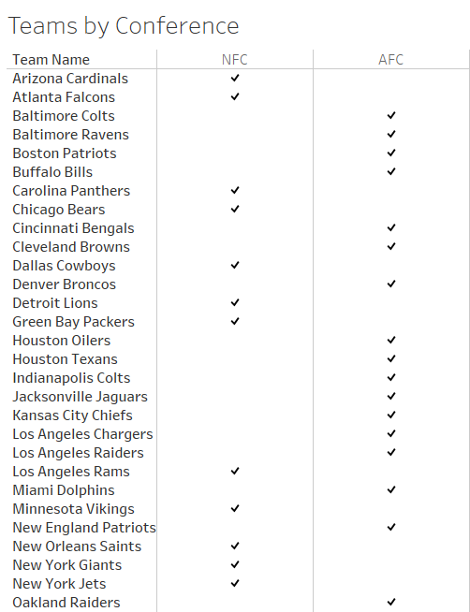

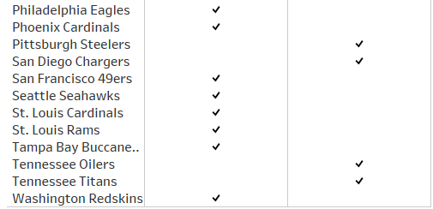

First, to examine this further, we look at a nationwide map of the stadium locations. Here we can see that there are some cities, Los Angeles and Baltimore included, in which the location changed. We’ll explore those below.

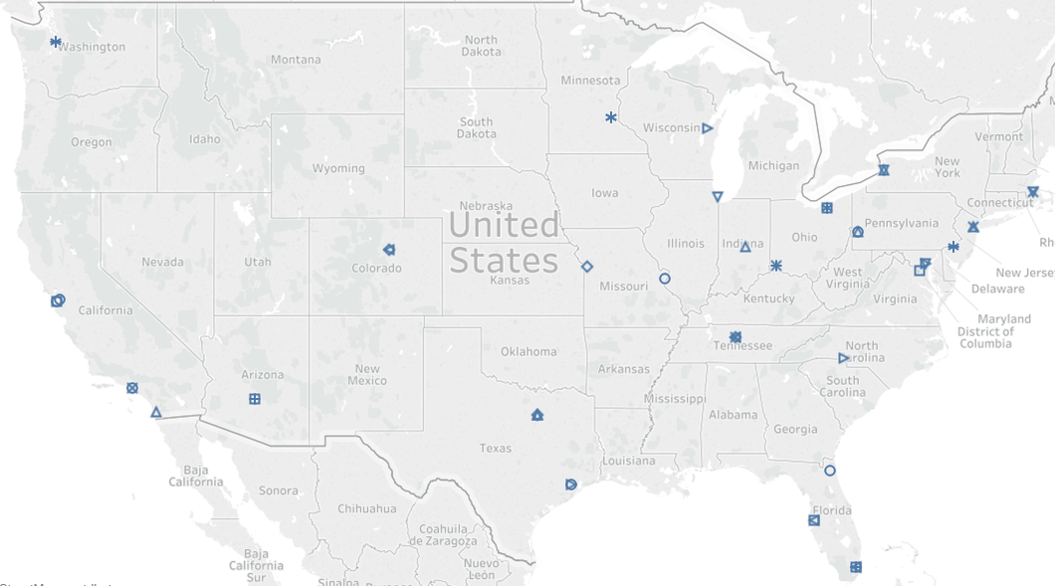

Looking further into the city redundancy, as described above, we see that some may be explained by changes in stadium locations. For example, below we see that the city of Baltimore has had two stadiums under different Stadium Names.

